**Phase 9: Reporting, Dashboards & Security Review**

**1.Reports (Tabular, Summary, Matrix, Joined) :**

Types of Reports in Salesforce

1. **Tabular Report** – Simple list of records without any grouping, similar to a basic Excel spreadsheet.
2. **Summary Report** – Records are grouped by rows, and summaries (like COUNT, SUM, AVG) can be applied.
3. **Matrix Report** – Records are grouped by both rows and columns, allowing a two-dimensional analysis.
4. **Joined Report** – Combines multiple report blocks (different report types) into a single view for comparison.

**1. Summary Report (Patient Report – Based on Gender)**

* Report Type: **Patient**
* Report Format: **Summary Report**
* Grouping: **Gender (Male, Female, Others)**
* Fields Used: Patient Name, Gender, Age, Contact Info (as required)
* Insights:
  + Shows **number of patients in each gender category**
  + Helps in understanding **demographic distribution**
  + Can be visualized using **Pie/Bar chart** for quick analysis

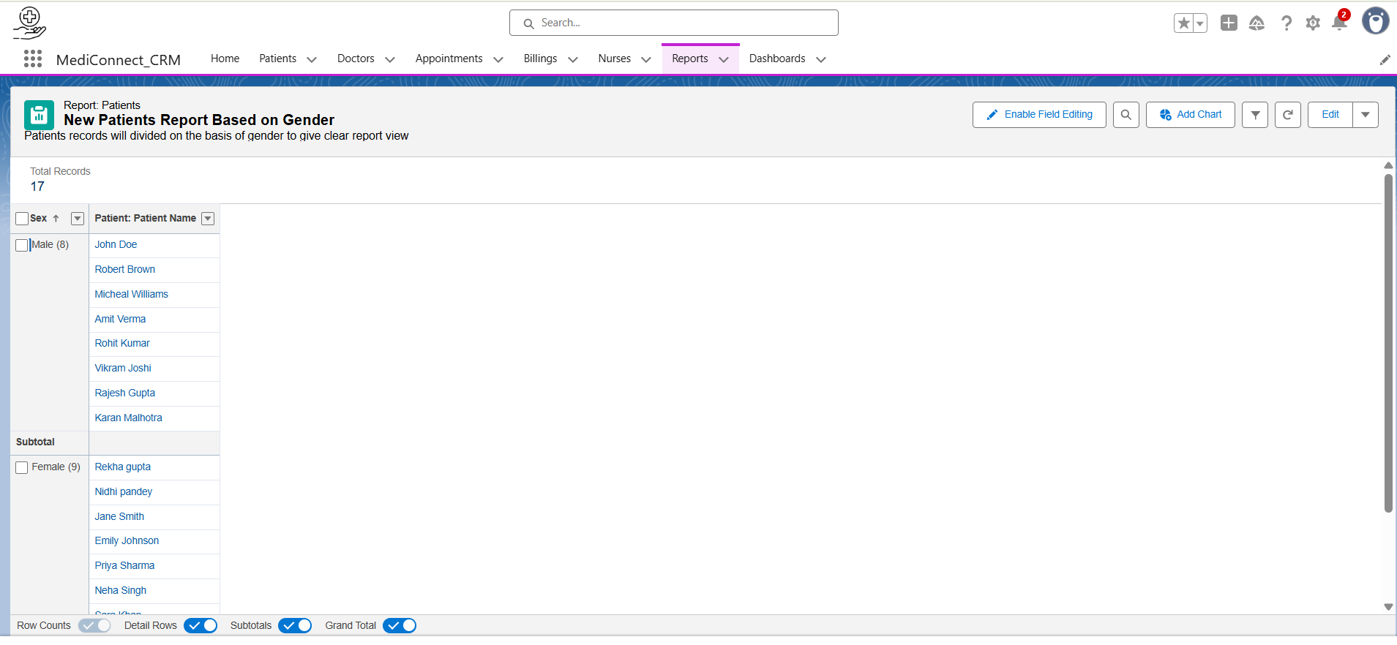

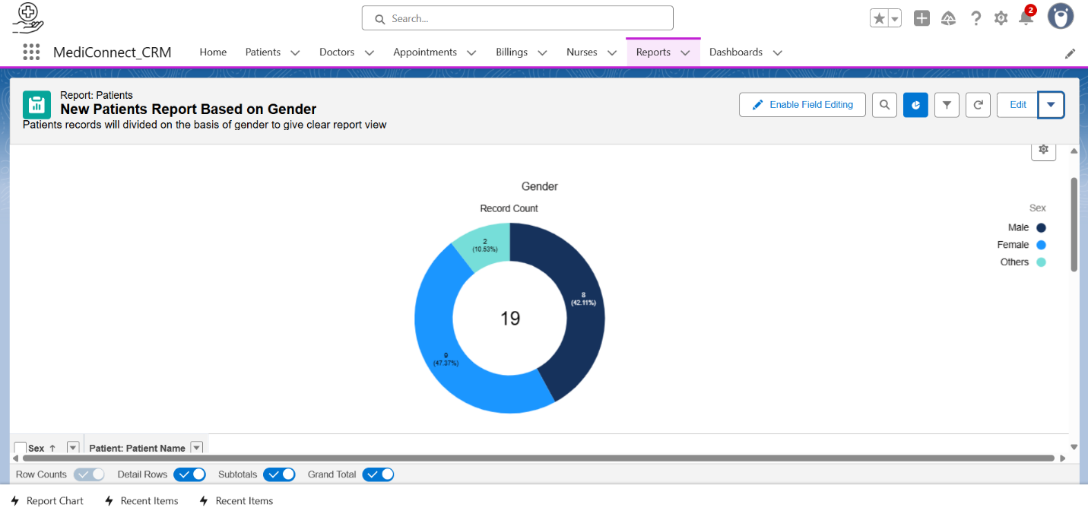

**2.Tabular Report - (Patient List by Age)**

Patient List by Age (just a flat list of all patients showing their name, age, and contact info).  
**No grouping, no charts — only a table format.**

**Insights:**

* **Report Name:** Patient Age Report
* **Type**: Tabular Report
* **Criteria**: Shows a simple list of Patients with selected fields like *First Name, Last Name, Age, Mobile Number*.
* **Purpose**: To quickly view patient details in a flat table without grouping.
* **Use Case**: Hospital admin can export this report to Excel for sharing patient lists based on age.

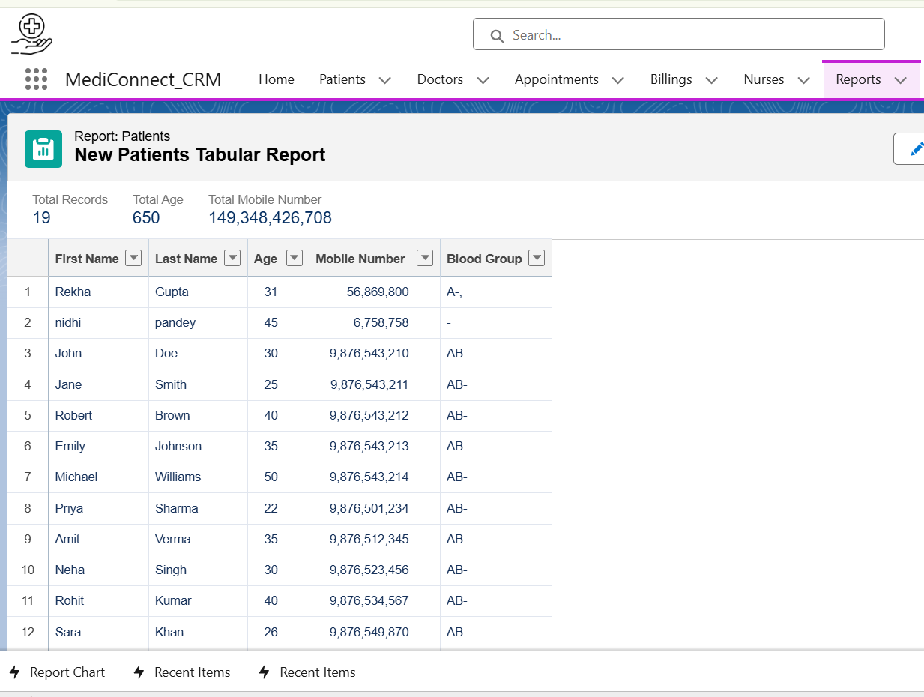

**3.Joined Report (Patient Overview):**

**Purpose:** To analyze patient records grouped by gender along with their related appointment and doctor information.

**Key Features:**

* Combines multiple report blocks in a single report.
* Allows grouping of data for comparison across related objects.
* Provides summary information within each block.

**Fields Used**:

* **Group Rows**: Gender (to separate Male, Female, Other categories)
* **Columns / Details**: Patient Name, Appointment Date, Doctor Name, Appointment Status

**Blocks:**

* **Patient Block**: Shows individual patient details.
* **Appointment Block (optional**): Displays related appointment details.
* **Doctor Block (optional):** Shows related doctor information.

**Usage:**

* Helps track distribution of patients by gender.
* Useful for analyzing appointments and doctor allocation per gender.
* Supports quick comparison across different related objects in one report.

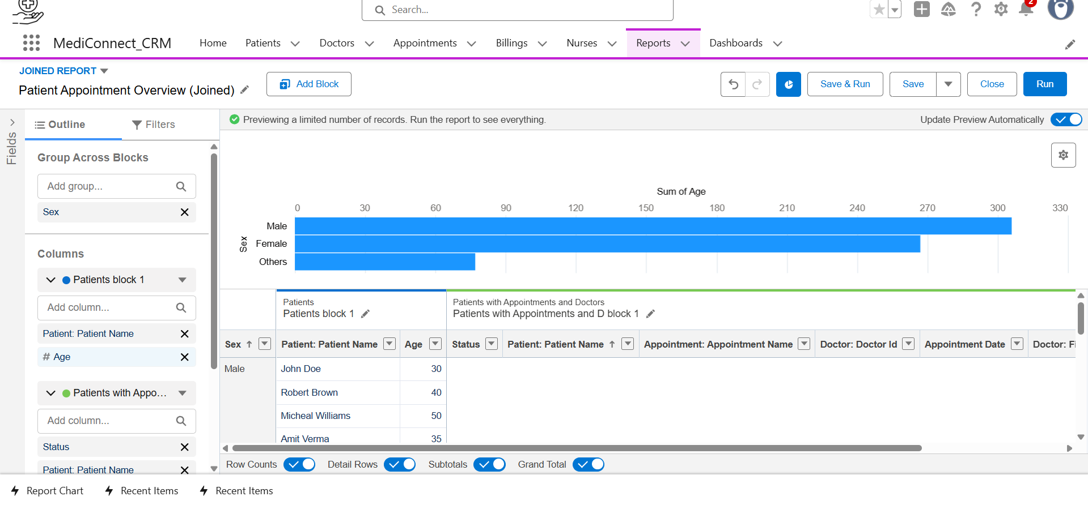

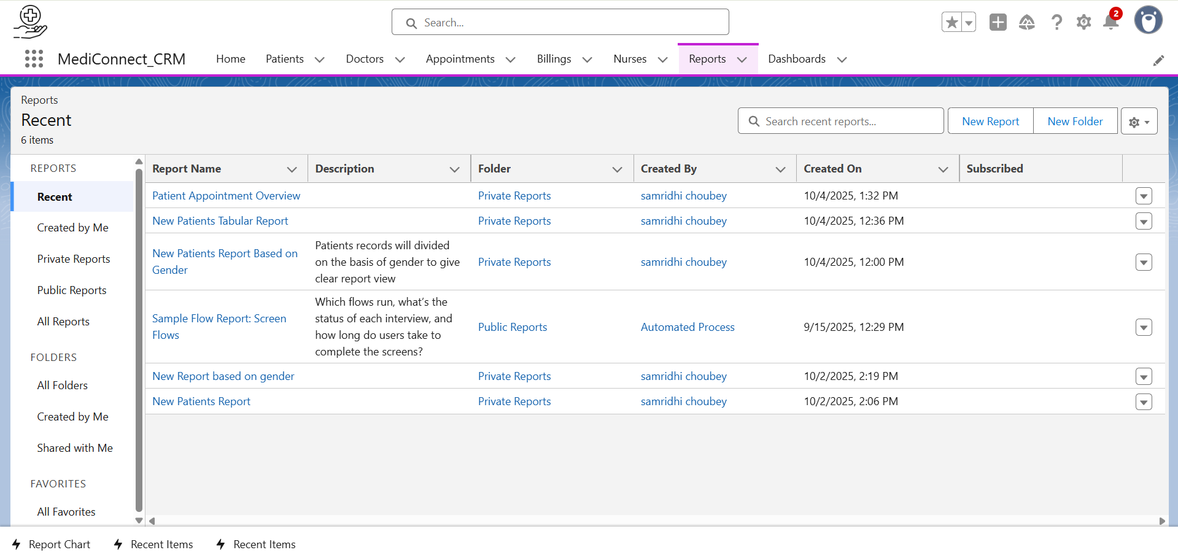

**2.Dashboards**

* **Definition:** Visual representation of key metrics and trends using multiple reports in one interface.
* **Components:** Charts, tables, metrics, gauges, and visual summaries.
* **Usage:** Provides quick insights into business performance and trends.

**MediConnect Dashboard 1:**

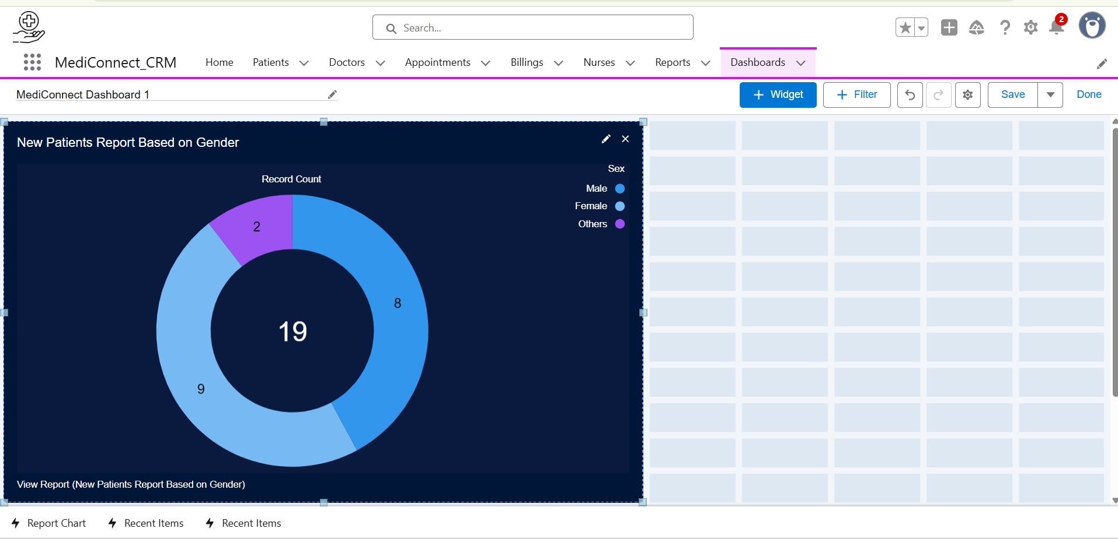

**MediConnect Dashboard 2:**

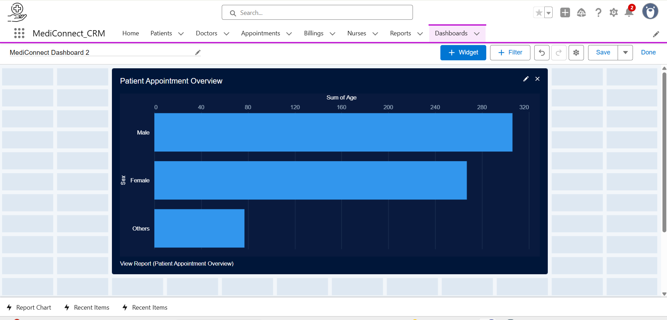

**MediConnect Dashboard 3:**

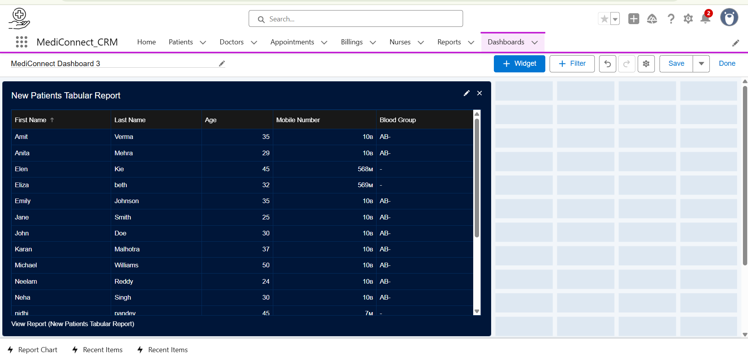

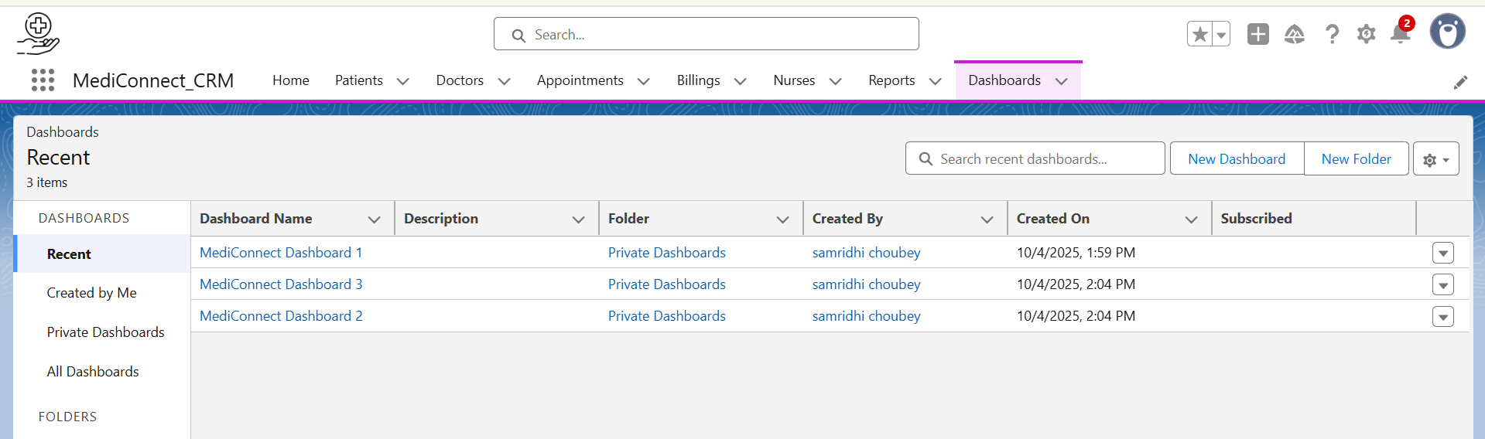

**3.Sharing Rules:**

Sharing Rules in Salesforce are used to extend record access to specific groups of users who do not have access based on the organization-wide defaults (OWD). They help share records automatically based on record ownership or criteria.

**Types of Sharing Rules:**

1. **Owner-Based Sharing Rule:**
   * Shares records owned by users in a particular role or group with users in another role or group.
   * Example: Share all *Patient* records owned by users in the “Doctor” role with users in the “Receptionist” role.
2. **Criteria-Based Sharing Rule:**
   * Shares records that meet certain field conditions with users or groups.
   * Example: Share *Appointment* records where **Status = "Confirmed"** with users in the **Billing Department** role.

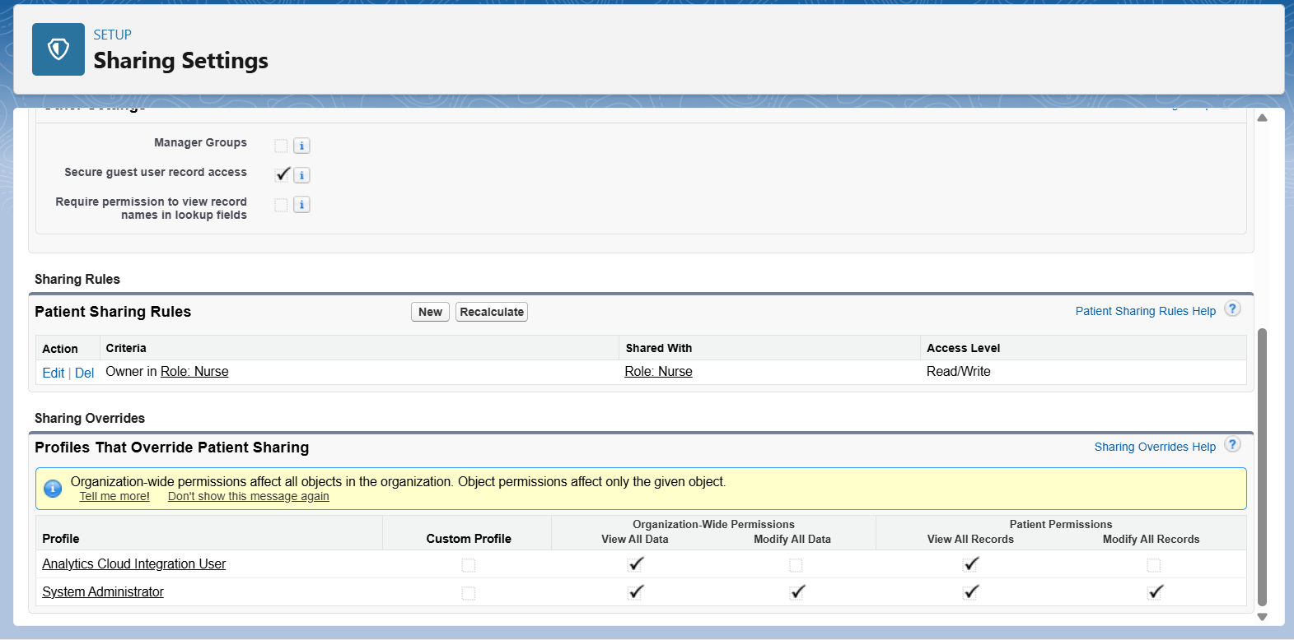

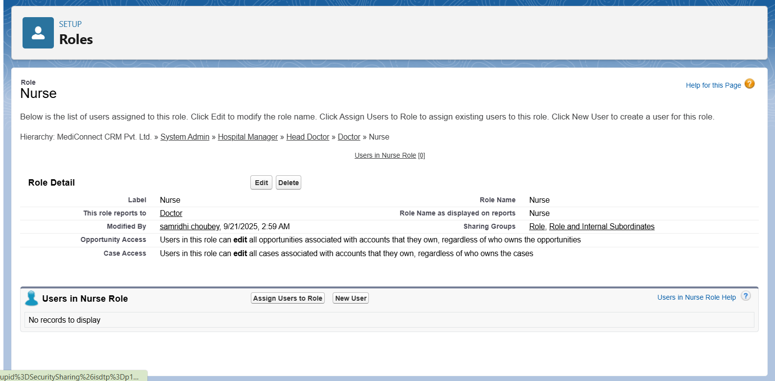

**4.Field Level Security:**

To control user access to specific fields on objects, ensuring that sensitive medical data remains confidential and is visible only to authorized users.

**Key Points:**

* Field Level Security determines which users can view or edit specific fields.
* It adds an extra layer of protection beyond object-level permissions.
* FLS can be applied through **profiles** or **permission sets**.

**Example Scenario (MediConnect):**

Let’s say we want to **hide the "Past Medical History" field** on the **Patient** object from users with the **Billing Officer** profile — since it contains sensitive medical information.  
Only **Doctors and other related field** should be able to see this field.

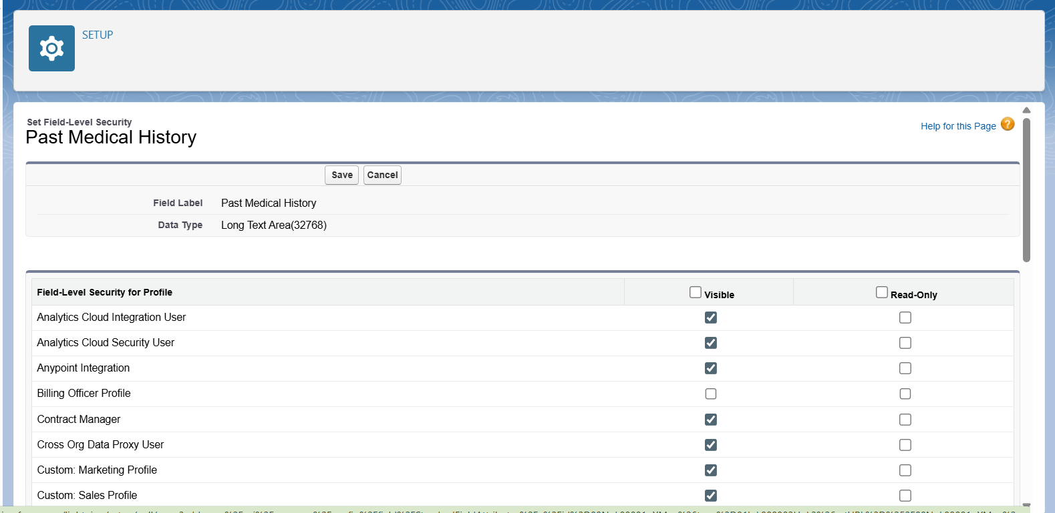

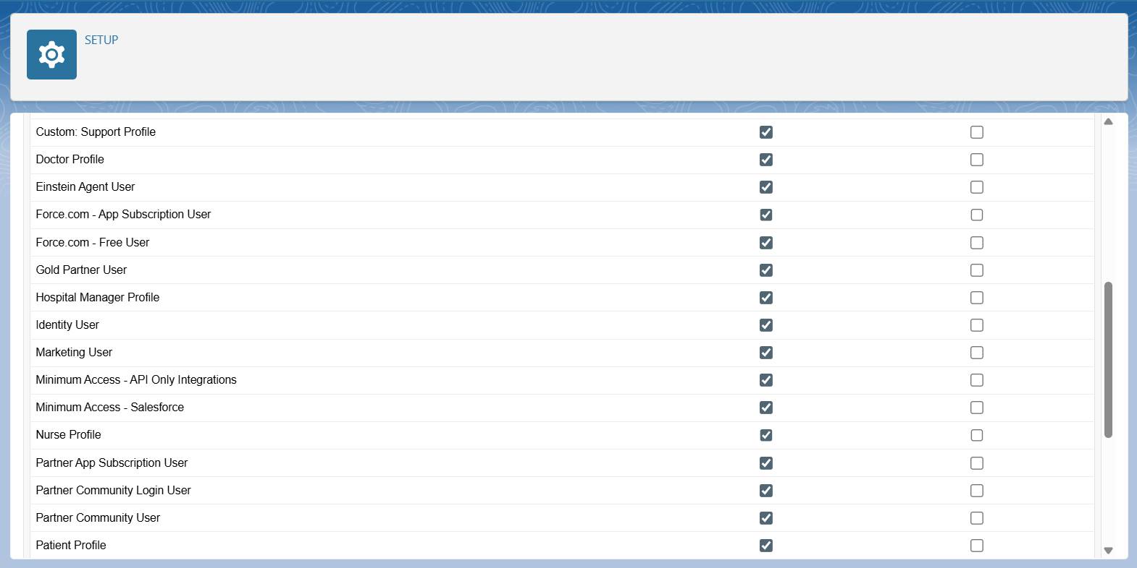

**5.Session Settings**

To enhance the overall security of user sessions by controlling login behavior, session timeouts, and access restrictions in the MediConnect application.

**Key Points:**

* Session Settings help manage **how long a user stays logged in**, **when reauthentication is needed**, and **which security measures apply** during a session.
* These settings protect the system from unauthorized access, especially in shared or public environments.

**Session Settings in MediConnect:**

1. **Enable Session Timeout Warning Popup** –  
   Alerts users before automatic logout due to inactivity.
2. **Force Logout on Session Timeout** –  
   Ensures inactive users are logged out for security.
3. **Session Timeout Value** –  
   Defines how long a session stays active (e.g., 2 hours).
4. **Lock Sessions to the IP Address from Which They Originated** –  
   Prevents session hijacking from another IP.
5. **Require Secure Connections (HTTPS)** –  
   Encrypts data transfer between browser and Salesforce.
6. **Restrict Login Access to Trusted Domains (if enabled)** –  
   Limits login access to authorized domains only.
7. **Enable Cache and Clipboard Controls** –  
   Prevents copying or storing sensitive Salesforce data locally.
8. **Enable Clickjack Protection for Non-Setup Pages** –  
   Protects users from malicious sites trying to embed Salesforce pages.

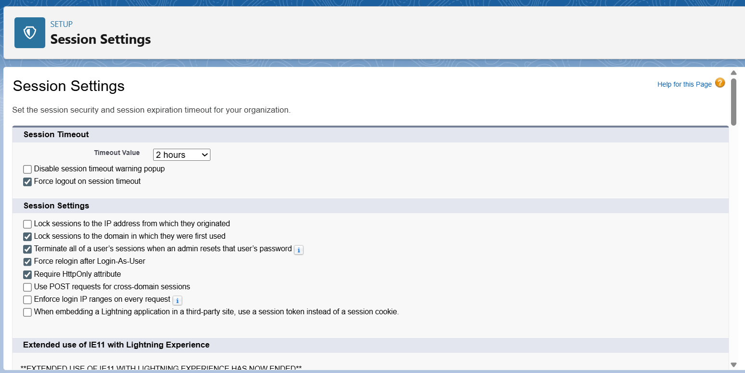

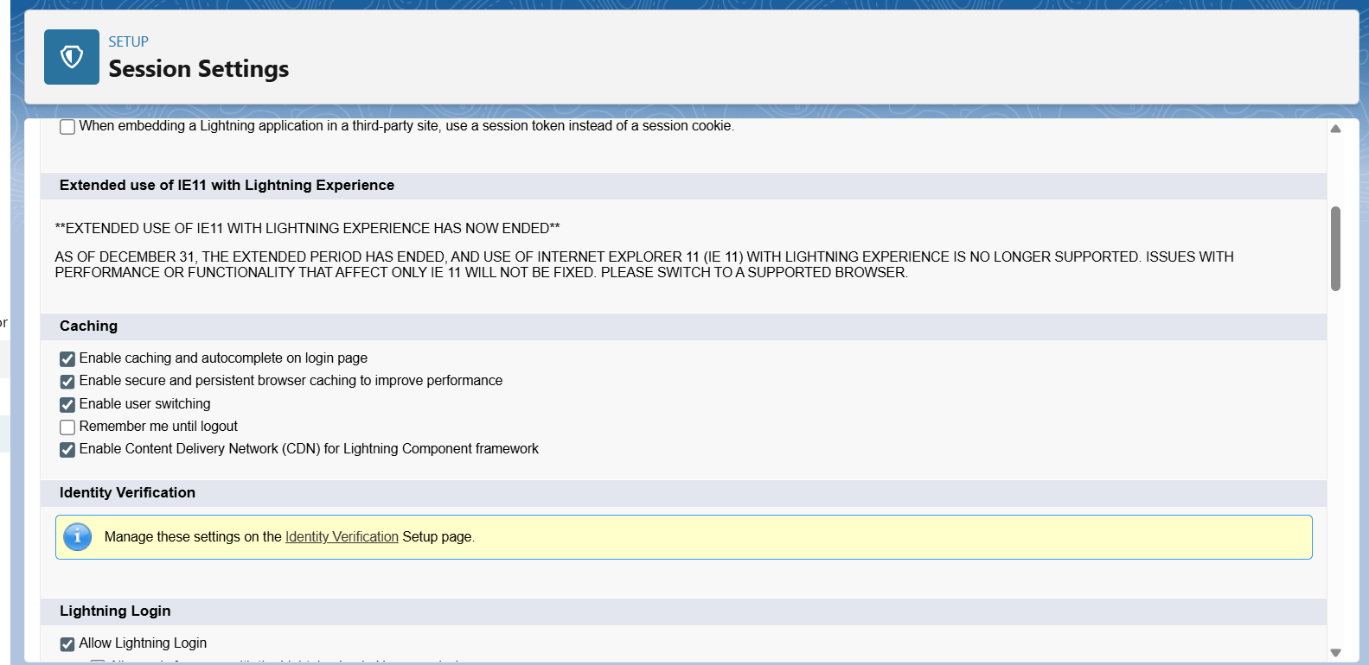

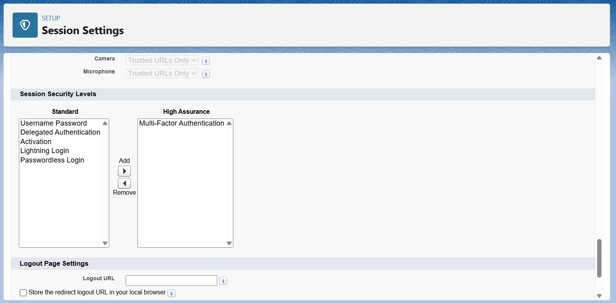

**6.Login IP Ranges:**

Login IP Ranges enhance security by restricting access to Salesforce from specific, trusted network locations (IP addresses). This prevents unauthorized logins from unknown or unsafe locations.

**Example Scenario**

If the hospital’s network operates within IP range **192.168.1.1 – 192.168.1.255**, then setting this range ensures:

* Users (like doctors, receptionists, and admin staff) can only log in from the hospital premises.
* Attempts to log in from outside (home or public Wi-Fi) will be blocked or require verification.

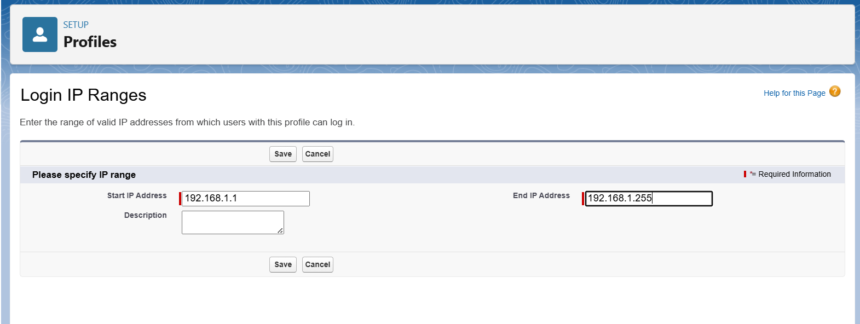

**7.Audit Trail**

Audit Trail helps track changes made in Salesforce setup by administrators. It records who changed what and when, providing transparency and security oversight.

**Key Features**

* Tracks modifications to:
  + Custom fields
  + Objects
  + Page layouts
  + Profiles, roles, and permissions
* Maintains history for up to **180 days**.
* Allows download of change history for compliance and auditing purposes.

**Example Scenario**

* Admin A updates the **Patient object layout**.
* Audit Trail records: **Admin A → Patient Layout → Modified on 06-Oct-2025**.
* Later, if an error occurs due to the change, you can identify who made it and when.